Pacific Ocean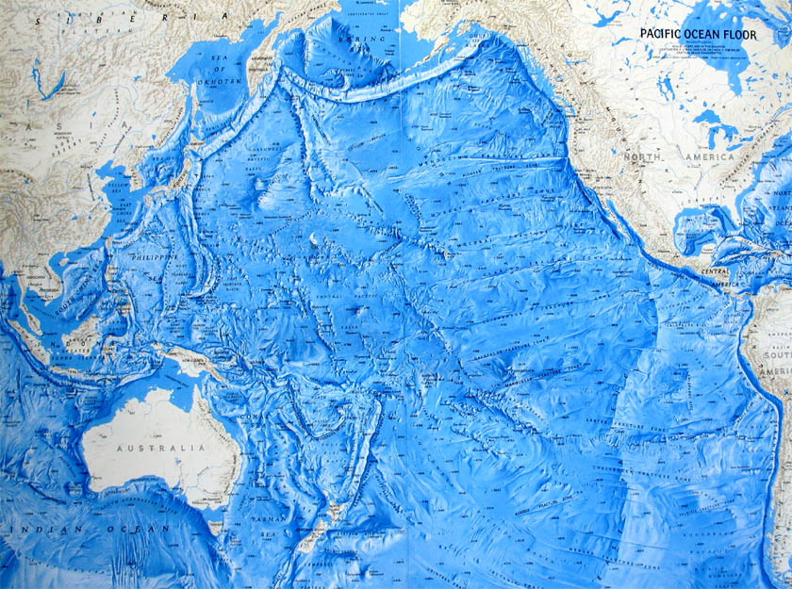

The Pacific Ocean is the largest ocean. It stretches from the north at the Arctic Ocean and goes all the way to the Southern Ocean just north of Antarctica. The Pacific Ocean is large enough to cover all of the Earth’s land combined. The Pacific Ocean is also the deepest ocean.
Size: The Pacific Ocean is 65.3 million square miles. It covers approximately 30 percent of the Earth’s surface.
Average Depth: The average depth of the Pacific Ocean is 15,215 feet. That is 2.88 miles deep!
Deepest Point: The deepest point in the Pacific Ocean is the Mariana Trench. It is 6.78 miles deep.
Bordering Countries: The Atlantic Ocean borders 20 countries. The largest landmass solely in the Pacific Ocean is New Guinea.
Average Temperature: The temperatures for the Pacific Ocean range from freezing to 86 degrees Fahrenheit.
Fun Fact: The Pacific Ocean is currently shrinking 2-3 centimeters per year because of the Tectonic Plates that create the Earth’s crust.
The Atlantic Ocean was named by Magellan from the Latin phrase “Mare Pacificum” which means peaceful sea.

